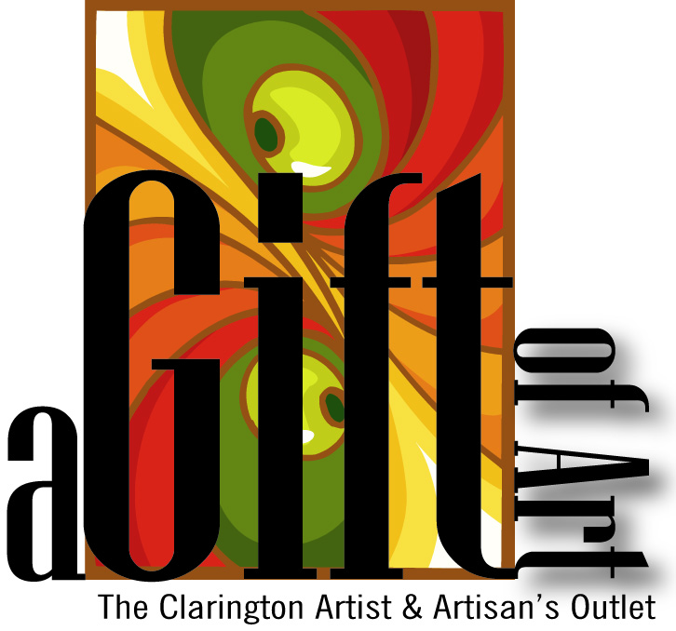
187 King Ave. E, Newcastle, ON
905-987-2264

★ Paint Night Package ★
Prices are given for a 2-hour party

★ Paint Night

☒ $150 for up to 10 people. Includes teacher and supplies cost.
☐ For more than 10 people it is $20 per person:
# of extra people: |  | x | $20 | = | $

★ Total
Total cost:

★ Subject of Painting
Painting will be acrylics on canvas. Please give any details here of what subject you would prefer to paint (landscape, flowers, etc, subject to teacher’s decision):

★ Date
Preferred date (subject to teacher’s availability):

★ Customer Information
Name:
Address:
Phone Number:
Email:

{Store use) Invoice Number:

